**Name: Amrit Kaur Sandhu**

**Student ID No: 100416424**

**Email ID: amrit.sandhu8@email.kpu.ca**

Website link: <https://sites.google.com/view/farmingapplication>

Use case diagram

USE-CASE: VEGETABLE STORE MANAGEMENT

The relationships among the pieces of the Vegetable Store Management System are graphically shown in this Use Case Diagram. It describes the system analysis technique for identifying, clarifying, and organising the system requirements of the Vegetable Store Management System. In this Use Case Diagram, the main actors of the Vegetable Store Management System are Admin, User, Dealer, and Customer, who perform various use cases such as Vegetable, Manage Store, Manage Stock, Manage Category, Manage Payment, Manage Bill, Manage Customer, Manage Users, and Full Vegetable Store Management System Operations.

The relationship between, as well as the use cases of the Vegetable Store Management System:

Vegetable, Manage Store, Manage Stock, Manage Category, Manage Payment, Manage Bill, Manage Customer, Manage Users, and Full Vegetable Store Management System Operations.

System User Entity: Manage Store, Manage Stock, Manage Category, Manage Payment, Manage Bill, Manage Customer, Manage Users, and Full Vegetable Store Management System Operations.

Dealer Entity: Check Requests, Create Orders, Deliver Items, Create Invoices, and Collect Payments are examples of Dealer use cases.

Customer Entity: Customer use cases include searching for vegetables, adding items to cart, and making a payment.

**CLASS DIAGRAM**

**Class diagram is prepared by me and Sagar.**

**Vegetable Store Management System Class Diagram shows the classes and their characteristics.**

**• Vegetable id, Vegetable Name, Vegetable Type, Vegetable Description.**

**• Store id, store name, store type, and store description are some of the store attributes.**

**• Stock id, stock items, stock number, stock type, and stock description are some of the stock attributes.**

**• category id, category item id, category type, and category description.**

**Relational database tables:**

**Bill vegetable items: -**

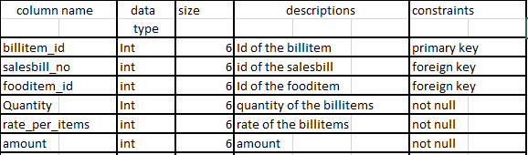

**Payment collection: -**

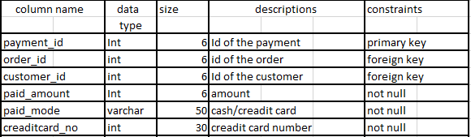

**Work experience:**

**Working in group is amazing and we have fun too. This project is little bit difficult for us as these are all new for us.**

**With the cooperation of Akash, Sagar, and Sanjot we do everything smoothly. There is one difficulty that we have to manage our time as everyone have their own schedules and plans.**